Іванов Кирил

ФІТ 2-8

Варіант 8

𝑓(𝑥) = 𝑥2 ⋅ 𝑠𝑖𝑛(𝑥)

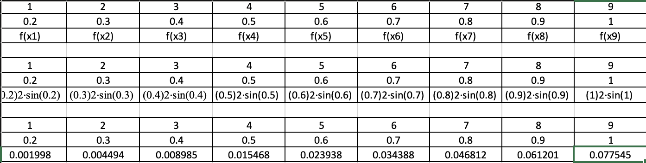

import numpy as np

from scipy.optimize import least_squares

import matplotlib.pyplot as plt

def fun(a, x, y):

return np.polyval(a, x) - y

x = np.array([0.1, 0.2, 0.3, 0.4, 0.5, 0.6, 0.7, 0.8, 0.9, 1])

y = np.array([0.000499, 0.001998, 0.004494, 0.008985, 0.015468, 0.023938, 0.034388, 0.046812, 0.061201,0.077545 ])

a0 = np.array([1, 1])

res_lsq = least_squares(fun, x0=a0, args=(x, y))

print("a0 = %.2f, a1 = %.2f" % tuple(res_lsq.x))

x_p = np.linspace(min(x), max(x), 20)

y_p = np.polyval(res_lsq.x, x_p)

plt.plot(x, y, 'o')

plt.plot(x_p, y_p, 'b')

plt.title("Метод найменших квадратів")

plt.grid(True)

plt.show()

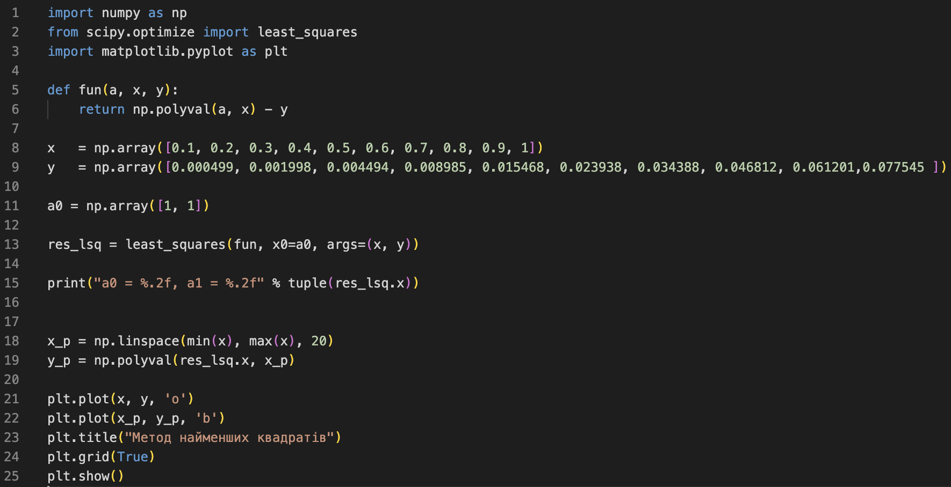

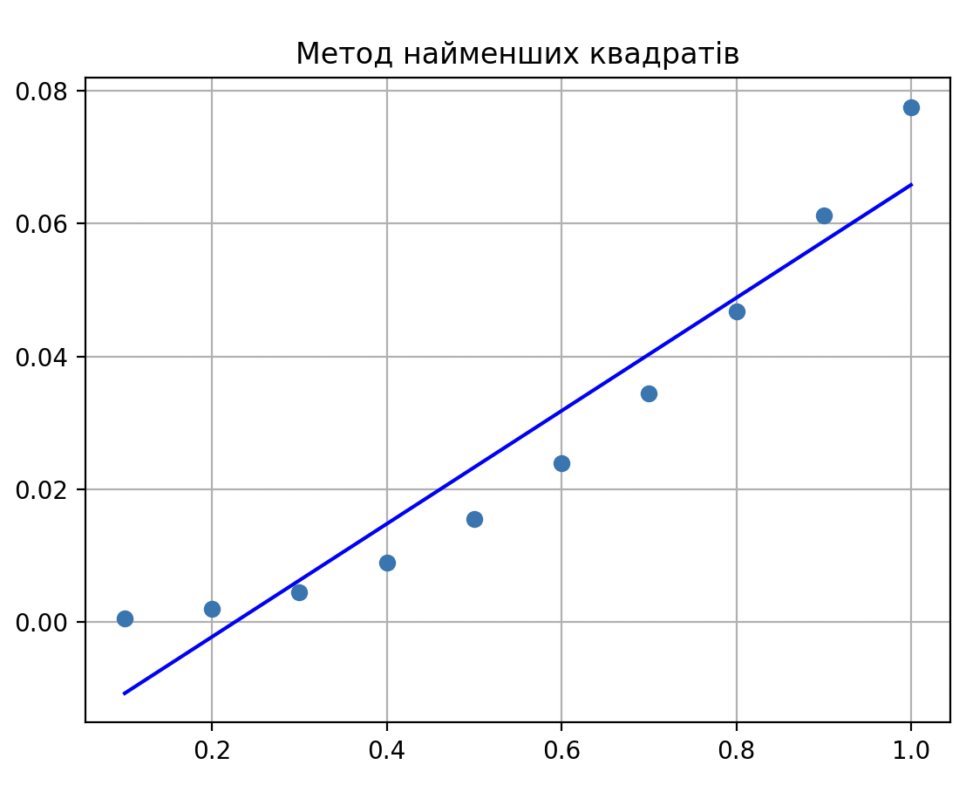



import numpy as np

from scipy.optimize import least_squares

import matplotlib.pyplot as plt

def fun(a, x, y):

return a[0] + a[1] * x + a[2] * x**2 -y

x = np.array([0.1, 0.2, 0.3, 0.4, 0.5, 0.6, 0.7, 0.8, 0.9, 1])

y = np.array([0.000499, 0.001998, 0.004494, 0.008985, 0.015468, 0.023938, 0.034388, 0.046812, 0.061201,0.077545 ])

a0 = np.array([1, 1, 1])

res_lsq = least_squares(fun,x0 = a0, args = (x, y))

print("a0 = %.2f, a1 = %.2f, a2 = %.2f"% tuple(res_lsq.x))

f = lambda x: sum([u * v for u, v in zip(res_lsq.x, [1, x, x**2])])

x_p = np.linspace(min(x), max(x), 20)

y_p = f(x_p)

plt.plot(x,y, 'o')

plt.plot(x_p, y_p, 'b')

plt.title("МНК_наближення параболою")

plt.grid(True)

plt.show()

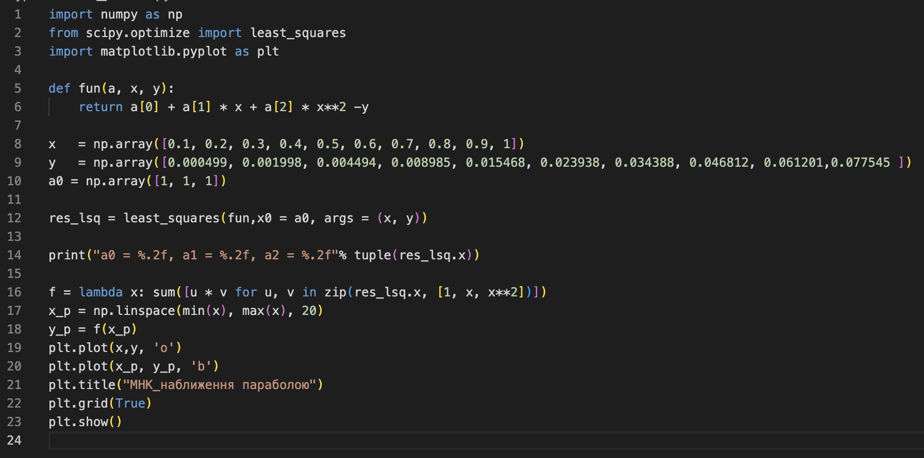



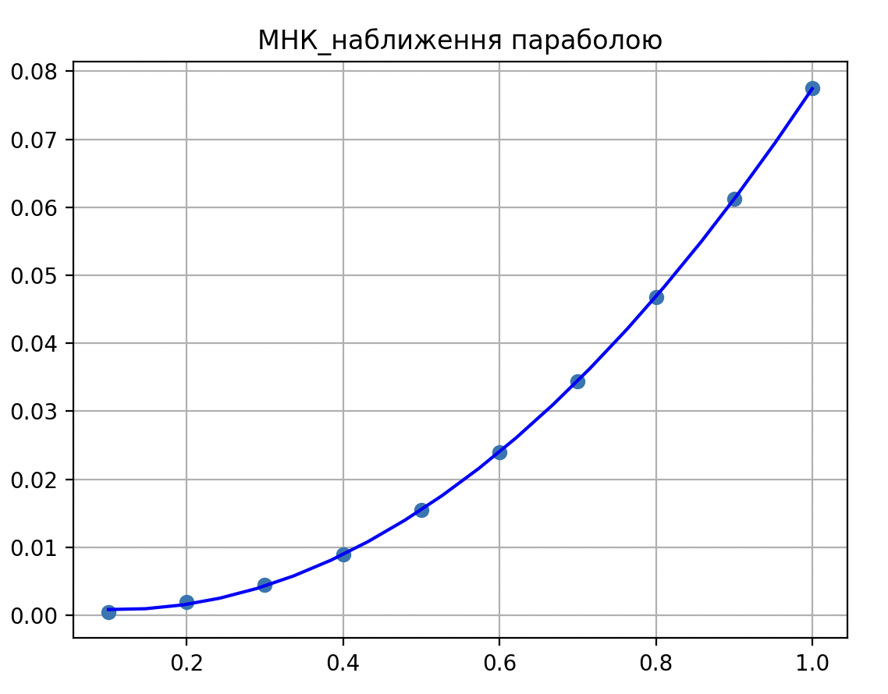

import numpy as np

import matplotlib.pyplot as plt

from scipy.optimize import least_squares

def func(x):

return x**2 * np.sin(x)

x = np.array([i * 0.1 for i in range(1, 11)])

y = np.array([func(xi) for xi in x])

print('x=', x)

print('y=', y)

def fun(a, x, y):

return a[0] * x**2 * np.sin(x) - y

a0 = np.array([1])

res_lsq = least_squares(fun, x0=a0, args=(x, y))

print("a0 = %.2f" % res_lsq.x[0])

f = lambda x: res_lsq.x[0] * x**2 * np.sin(x)

x_p = np.linspace(min(x), max(x), 100)

y_p = f(x_p)

plt.plot(x, y, 'o')

plt.plot(x_p, y_p, 'b')

plt.title("МНК_наближення параболою")

plt.grid(True)

plt.show()

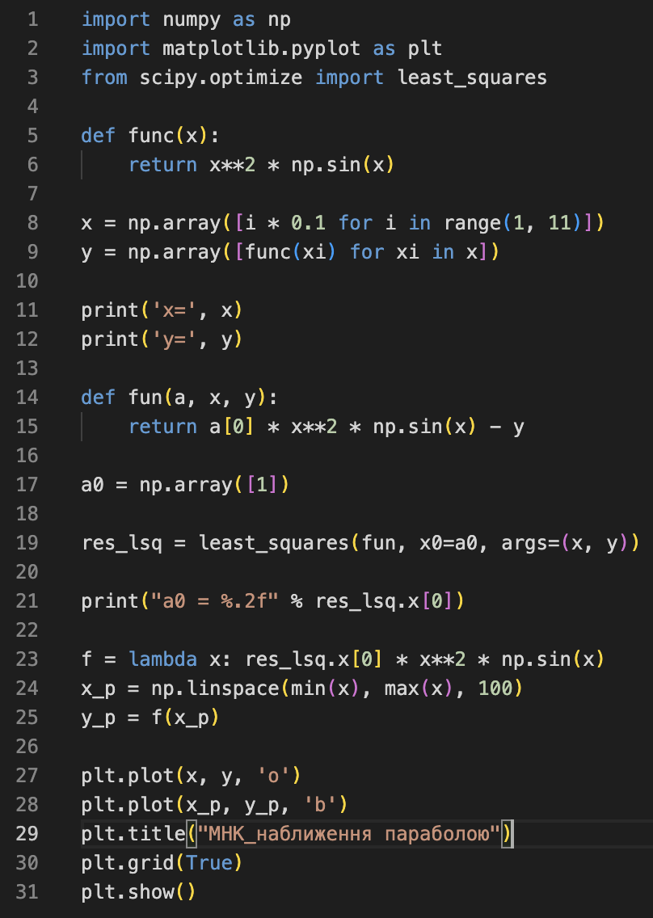

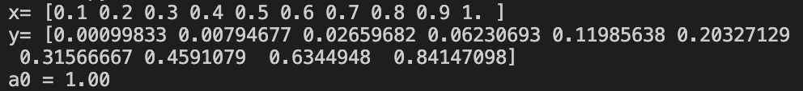

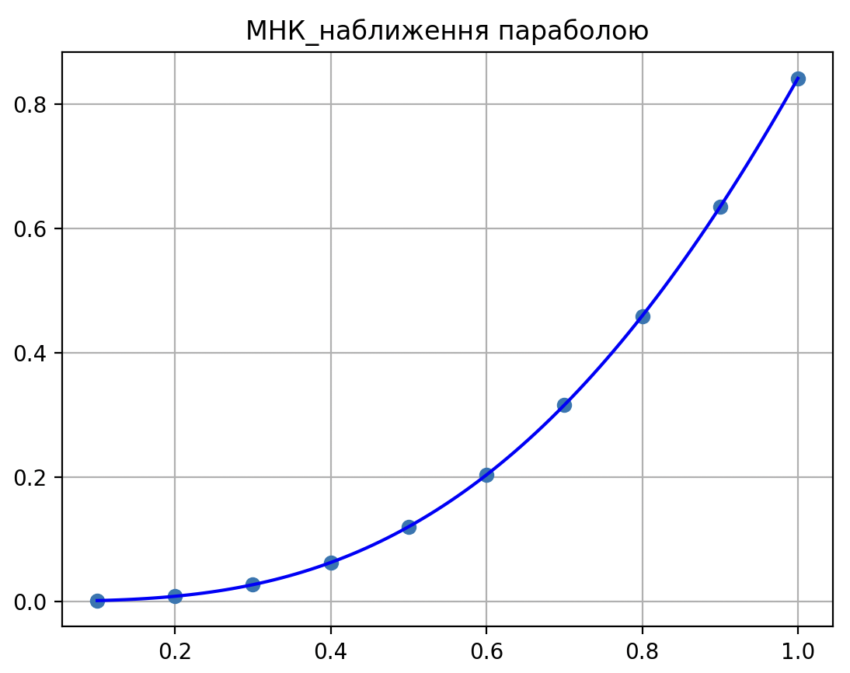

import numpy as np

import matplotlib.pyplot as plt

from scipy.optimize import least_squares

def func(x):

return x**2 * np.sin(x)

x = np.array([i * 0.1 for i in range(1, 11)])

y = np.array([func(xi) for xi in x])

print('x=', x)

print('y=', y)

def fun(a, x, y):

return a[0] * x**2 * np.sin(x) - y

a0 = np.array([1])

res_lsq = least_squares(fun, x0=a0, args=(x, y))

print("a0 = %.2f" % res_lsq.x[0])

f = lambda x: res_lsq.x[0] * x**2 * np.sin(x)

x_p = np.linspace(min(x), max(x), 100)

y_p = f(x_p)

plt.plot(x, y, 'o')

plt.plot(x_p, y_p, 'b')

plt.title("МНК_наближення прямою")

plt.grid(True)

plt.show()

